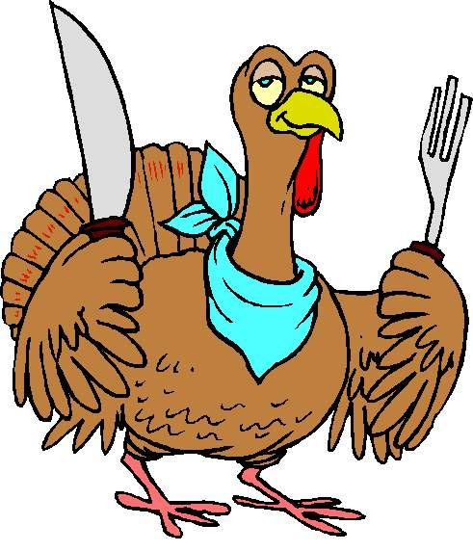
This Photo by Unknown Author is licensed under CC BY-NC-ND
Left Over Bowl
Race Date: 26 Nov 201

Div Finish Corrected Seconds *
Rank Boat Name Sail No. Rating Time Time Behind Owner / Skipper

Spinnaker PHRF Time on Distance / Start Time 13:00:00 / Dist.5.30 * Time Behind is Sec / Mile

1 Orion 68120 132 14:20:40 01:09:00 Jon Opert
2 Resolute 33 72 14:17:20 01:10:58 22 Frank Albert
3 Skoot 369 69 14:17:07 01:11:01 23 Dan Lewis
Non Spinnaker PHRF Time on Distance / Start Time 13:05:00 / Dist.5.30 * Time Behind is Sec / Mile

1 Cheap Sunglasses 93273 84 14:06:07 00:53:42 Irv Buck
2 M'Luv 553 243 14:20:24 00:53:56 3 Elsie Whitman
3 Athena 6431 150 14:13:15 00:55:00 15 Michael Viens
5 Ramblin Rose 575 246 DNF Jacob Keaton
Questions? Contact: Gotcha

